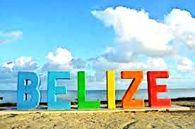
Mission Trip
July 30th - Aug 5th

Here’s My Dollar Fund Raiser

1) I love the God so here’s my dollar ___________________________________

2) I love missions so here’s my dollar ___________________________________

3) I can’t go so here’s my dollar ________________________________________

4) Don’t know where Belize is so here’s my dollar ________________________

5) I am praying for you here’s my dollar _________________________________

6) I’m so happy for you here’s my dollar _______________________________

7) I love orphans so here’s my dollar ___________________________________

8) I love the ocean so here’s my dollar _________________________________

9) I love the jungle so here’s my dollar _________________________________

10) I love to sing so here’s my dollar ___________________________________

11) I love Youth Camp so here’s my dollar _______________________________

12) I love soccer so here’s my dollar _____________________________________

13) I want to bless you so here’s my dollar ________________________________

14) I Love the Bible so here’s my dollar ___________________________________

15) I love to pray so here’s my dollar _____________________________________

16) I love to travel so here’s my dollar _____________________________________

17) I love ministry so here’s my dollar _____________________________________

18) I love new friends so here’s my dollar __________________________________

19) I love seafood so here’s my dollar ______________________________________

20) I have never been so here’s my dollar __________________________________

